**4.5 Graphs of Sine and Cosine Function**

**Objective: Sketch graph using amplitude and period**

Remember, we touched on this first semester… we watched a youtube video that corresponds the sine and cosine graph to the points on the unit circle.

Image of sine function (one rotation of unit circle) **y = sin x**

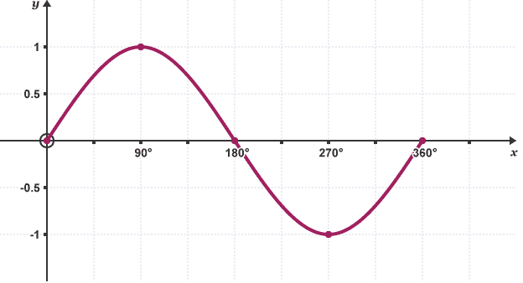

Image of cosine function (one rotation of unit circle) **y = cos x**

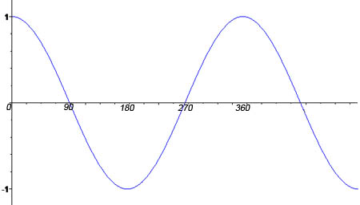 Note: this image goes   
 past 360 degrees so it is   
 slightly more than one   
 rotation (period). One   
 period would stop at the   
 peak above 360 degrees.

Use the image on the top of page 320 to identify key points in your note.

Have a discussion about how the key points on the sine and cosine function graphs, relate to those same points on the unit circle.

Definition of Amplitude of Sine and Cosine

The amplitude of *y = a sin x* and *y = a cos x* represents half of the distance between the maximum and minimum values of the function and is given by:

Amplitude = | a |

Period of Sine and Cosine Functions

Let b be a positive real number. The period of *y = a sin bx* and  
*y = a cos bx* is give by:

Period = $\frac{2π}{b}$

**Homework** Pg 326 #5-11 (odd), 31, 33